Presenters Schedules & Presentation Descriptions

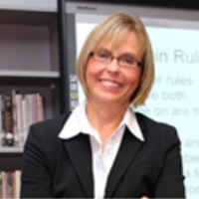
Keep Students From Falling Into The Cracks.
Monday – July 13th, 9:00 a.m. to 10:00 a.m. (PST)

Getting and keeping students engaged is challenging enough in the regular classroom, but increases in difficulty in online and virtual learning environments. Brenda will share some of her most creative strategies to pique student interest, making learning more meaningful while assuring the most important academic content gets across to students.

Brenda McKinney

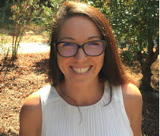
Getting Gritty In The Age Of Remote Teaching.
Tuesday – July 14th, 9:00 a.m. to 10:00 a.m. (PST)
Patricia shares practices for crafting tasks, including grit and growth mindset, to develop self-directed learners. She’ll discuss digital tools and strategies that make it easier to engage students and maintain their interest in remote teaching.

Patricia Dickenson
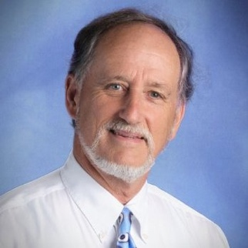
Helping Students Find Themselves.
Wednesday – July 15th, 9:00 a.m. to 10:00 a.m. (PST)

Language arts is a natural platform to help our students explore their identity through writing activities on family, culture, and other influences, on values, beliefs and future goals. Sharing their explorations in the classroom or virtually has proven a meaningful way to maintain student interest and build a sense of community. John will talk about the great success he has had with students from his sophomore English classes over the last twenty years and will share a recent culminating presentation done via zoom.
John Creger

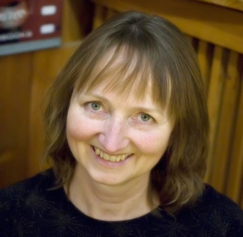
Writing Workshops That Really Work.
Thursday – July 16th, 9:00 a.m. to 10:00 a.m. (PST)
Does writing seem hard to teach? Find out what’s most effective in teaching writing. Learn from your own writing insecurities as you acquire strategies that will get your students not only writing for longer periods of time, but with more voice, originality, and confidence. Let’s take your questions, fears, and dreams, and transform them into steps for how to succeed.
Deb Lund

Virtual Teaching Tools You Can Use Any Time.
Friday – July 17th, 9:00 a.m. to 10:00 a.m. (PST)

With the flurry of just surviving the transition to online schooling behind us, now may be the time to step back and look for ways to use virtual learning apps as an adjunct to live class instruction as well as flipped lessons and virtual teaching. Join the fun as we explore interactive apps (ranked by learning curve) such as EdPuzzle, WooClap, Kahoot, Parlay, and FlipGrid.

Michael Boll

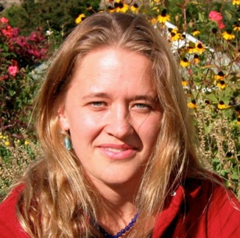
Trauma-Informed Teaching.
Monday – July 20th, 9:00 a.m. to 10:00 a.m. (PST)
In order to reach and support all students, we must approach everything we do through a trauma-informed lens. This means that we see the whole child, that we take life experience into account when planning instruction, that we understand common responses to trauma, and how that can impact our students in a learning environment.

Stacey Shaw

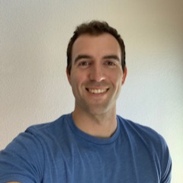
Beyond Fake News & Bias: Tips to Decipher Media.
Tuesday – July 21st, 9:00 a.m. to 10:00 a.m. (PST)
When we don't watch the news, we are uninformed, but watching the news makes us misinformed. Discover how media has been used throughout history to control the hearts and minds of the masses. This session will provide you with the tools, strategies, and ability to break down the walls of fake news and perceptual bias that keep us from the truth.
Corey Davis

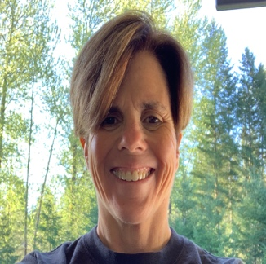
Let’s Get Physical: Exercises to Stir Up Energy & Brain Power.
Wednesday – July 22nd, 9:00 a.m. to 10:00 a.m. (PST)
Close the computers, put the pencils down, and bring a little exercise into the classroom! Get the student’s engines going, and their brains in gear, with these fun ideas for reviving energy and stirring up thinking power.

Terree Marvin

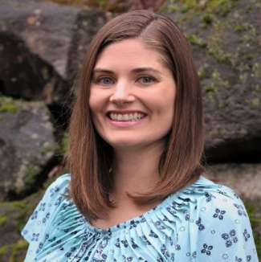
Staying Happy In Challenging Times.
Thursday – July 23rd, 9:00 a.m. to 10:00 a.m. (PST)
Social and emotional learning is especially important during these challenging times. We need to remind ourselves and our students that stress and unhappiness are states we can control. Join Charity as she discusses the action steps we can use to take control of our happiness and share that knowledge with our students.
Charity Staudenraus

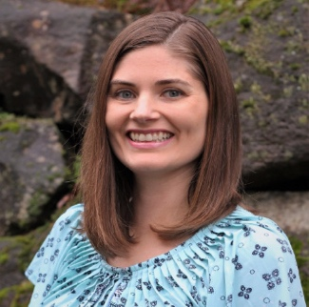
Prioritizing What Matters: Putting the Screen Down.
Friday – July 24th, 9:00 a.m. to 10:00 a.m. (PST)
We need our digital devices, but they are addictive and cannibalize our time. Teachers need to be extra creative to engage kids virtually, especially when so many are spending many hours on devices apart from school time. Charity discusses ways to minimize screen time for ourselves and students toward improving our mental and social health.

Charity Staudenraus

Presenters Bios

Michael Boll, M.A. is an Apple Distinguished Educator, Podcaster, and Technology Coach at the International School Bangkok. Michael enjoys helping educators, parents, and students harness the transformative powers of technology and is an enthusiastic instructional designer and presenter. He works to make his courses and presentations information packed, slightly provocative, and fun. Michael has a teenage son with profound autism and is keenly interested in the special-needs community and its population of diverse learners. This interest led Michael and his wife, Lori Boll, to open an innovative school in Shanghai (ShineAcademy.asia) for their son.
For more information on Michael Boll, and to view his courses, go to
www.hol.edu.

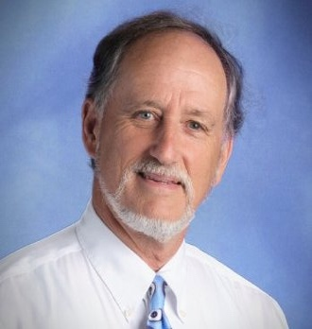
John Creger, Ph.D., is an English teacher and has been learning from sophomores at American High School in Fremont, CA, since 1988. In his publications and presentations since 1998, John communicates to educators what his sophomores’ continuing response to his Personal Creed Project teaches him about a deeper kind of literacy. In 2015, John launched Thriving at the Core Presentations to share his developing approach with colleagues in their districts. He earned a B.A. from the University of California at Berkeley, and an M.A. from San Francisco State University, both in English. In recognition of the Personal Creed Project, the National Council of Teachers of English and the National Writing Project presented John the James Moffett
Memorial Award for Teacher Research.
For more information on John Creger, you may email him at
jcreger@fusdk12.net

Cortland Davis, M.A.T., received his A.A. from Mt. Hood Community College, his B.A. from Wright State University, and his M.A.T. from Concordia University. Corey has experience teaching Social Studies, specifically U.S. History and A.P. Human Geography, at the high school level. He has served as an assistant baseball coach at his high school for the past five years, served on the AVID site team, and Equal Opportunity Schools site team. For more information on Cortland Davis, and to view his courses, go to www.hol.edu.

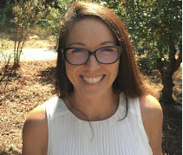
Dr. Patricia Dickenson is an Associate Professor of Teacher Education, a Program Lead for the Bachelor of Arts In Interdisciplinary Studies with the Preliminary Multiple and Single Subject Credential. Her research area focuses on mathematics, professional development, and technology. Dr. Dickenson has worked in higher education for the past eight years, published two books, and has over 12 book chapters and articles.
For more information on Dr. Patricia Dickeson, and to view her courses, go to www.hol.edu.

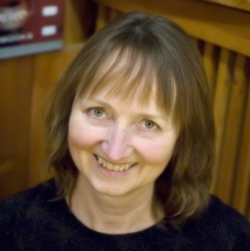
Deb Lund, M.A. is a bestselling children’s author, a creativity coach who partners with those who want more joy and meaning in their lives, and a past classroom and music teacher, teacher-librarian, and founding director of an arts-based school. Deb is a popular presenter at schools, libraries, and conferences. Her master’s project focused on teaching writing, and for the past few decades, she has taught teachers, students, and writers of all ages. Deb is especially passionate about supporting those who share her commitment to getting kids reading and writing. For more information on Deb Lund, and to view her courses, go to www.hol.edu.

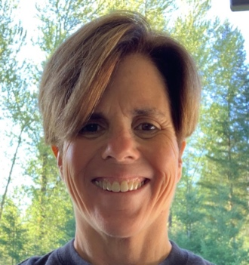
Terree Marvin, B.A. is a teacher of history and writing to 7th and 8th graders as well as PE to grades K-12 at River Home Link in Battle Ground WA. It's an alternative school where the parents are our co-teachers, and learning happens at both school and home. Terree's goal is to inspire her students by motivating them to strive for excellence and to help them face life's challenges. To contact Terree Marvin, you may email her at marv772@aol.com

Brenda McKinney, M.A. & CEO of Vancouver, WA based BrainVolution, is a developer and dynamic facilitator of workshops that teach practical thinking and learning tools for raising student achievement with the brain in mind. She brings 30+ years of experience at the elementary, middle school, high school, and university level as a mentor teacher, consultant, motivational speaker, university instructor, and reading specialist. Brenda has her Master’s in Education from Washington State University and is nationally certified in Brain-Based Learning through the renowned Jensen Corporation, led by Eric Jensen, a noted international spokesperson for neuroscience and education. For more information on Brenda McKinney, and to view her courses, go
to www.hol.edu.

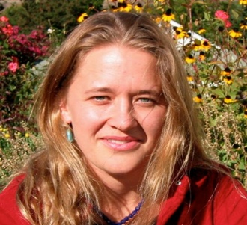
Stacey Shaw, M.Ed. has taught all ages, from kindergarten through college in subjects ranging from English Language Arts and Social Studies to English as a Second Language and Spanish. She received her Bachelor of Arts from The Evergreen State College in 1992. Her undergraduate studies focused on bilingual education, Spanish language, and Latin American Studies. She received her Master of Arts in Education from Prescott College in 2003. Stacey is currently working on her Doctorate of Education at Lewis and Clark College.
For more information on Stacey Shaw, and to view her courses, go to www.hol.edu.

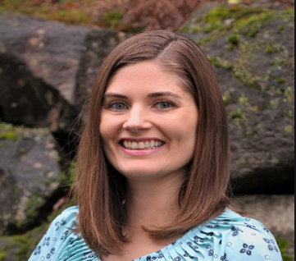
CHARITY STAUDENRAUS, M.A.T., received her B.A. from Willamette University, her M.A.T. from Willamette University. Charity has experience teaching math, science, social studies, business, and language courses at the middle and high school level. She is currently serving on the 2014-2017 Oregon Science Content and Assessment Panel as well as the Oregon Instructional Materials Criteria Development Committee. Also, Charity is consulting on a Rutgers University and W.P.I. Project funded through multiple Department of Education and National Science Foundation Grants.
For more information on Charity Staudenraus, and to view her courses, go to www.hol.edu.

